Tell us – Our performance against the complaints handling code 2024/2025

- Background and performance

In July 2024 we identified that we needed to make changes to our complaint handling processes to ensure that we were compliant with the new code. We submitted our revised self-assessment to the Housing Ombudsman on 30 September and published our last report at the same time.

The information below provides an overview of the complaints we received during the 12-month period from April 2024 to March 2025.

During 2024/2025 we received a total of 66 complaints.

Quarter | Complaint number
1 | 23
2 | 21
3 | 9
4 | 13

This increased from 58 complaints which were recorded in 2023/2024.

During 2024/2025
- No complaints were refused.
- 60 complaints were resolved at stage one
- Five complaints were resolved at stage two
- One complaint was resolved at stage three (which was prior to our complaints process changing to match the new code).
- Two complaints throughout the year showed that the process wasn’t followed within the correct timeframe. One complaint was verbally responded to, but the outcome letter was not sent within expected timeframes. The other complaint was about a staff member, and a thorough investigation on behalf of the human resources team had to take place resulting in timeframe delays. Both instances occurred prior to the updated code being submitted to the Housing Ombudsman on the 30 September 2024
- All complaints after our revised self-assessment to the Ombudsman were completed within the correct timeframes.
- From quarter three in 2024 we began recording more clearly our complaint outcomes a summary is provided in the table below.

Complaint | Upheld | Partially Upheld | Not Upheld | Total
Staff member | 3 | 1 | 5 | 9
Anti-social behaviour | 0 | 1 | 6 | 7
Standard of support | 0 | 1 | 2 | 3
Accommodation maintenance | 2 | 0 | 0 | 2
Equality and Diversity | 0 | 0 | 1 | 1
Total | 5 | 3 | 14 | 22

- Analysis of complaints

  - Reasons for complaints yearly comparison
- Anti-social behaviour has been the most common reason for complaints over the past few years.
- Complaints about accommodation maintenance have seen an improvement compared to last year.
- The graph below shows a comparison from 2022 onwards.
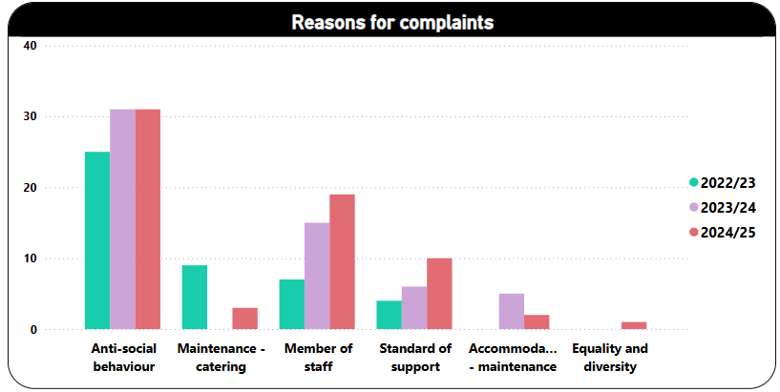
  - Where the complaints came from
- Clients were the most common complainants with 36, accounting for 55% of all complaints throughout the year. This was an increase of 10 complaints from 2023/2024.
- Complaints from members of the public decreased by five, with 26 complaints recorded.
- Complaints on another’s behalf increased by two from 2023/2024.
- Complaints from the local authority increased by one from 2023/2024.

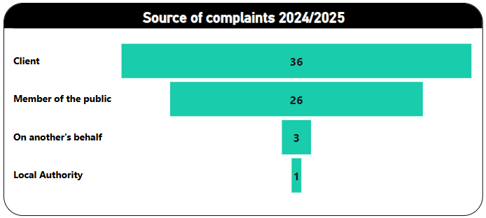

  - Complaints from client’s analysis
- Over the past year we’ve had nine clients complain more than once.

- The table below shows the amount of time clients have been in service when they made their complaints. 58.3% of clients (21) who have made a complaint this year have been in service for less than six months.

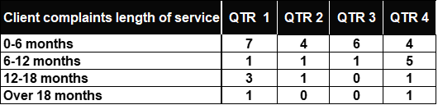

- The table below shows that 52.8% of our complaints came from clients aged 16 to 25 year. The highest number of client complaints came from clients aged in the 26-30 age group and the 51-59 age group with six complaints each. Clients over 70 years of age did not report any complaints.

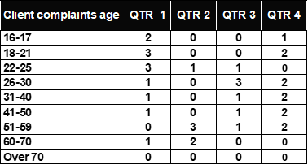

3.0. Housing Ombudsman’s report and findings
- No complaints were escalated to the Housing Ombudsman; therefore, we haven’t received any findings of non-compliance.

4.0. Complaints and tenants’ satisfaction measures (TSM)
- The tenant satisfaction measures are linked to our annual client survey.
- TSM9 asks clients whether they have made a complaint in the last 12 months. 19.7% of clients said that they had.
- TSM09 asks how satisfied clients were with how complaints were handled, 51.8% of these clients gave a positive answer.
- The tenant satisfaction measures include measurements about the number of complaints in relation to the size of the landlord and complaints handling. Our performance is outlined below.
- CH01 - number of complaints relative to the size of the landlord.
We had 60 stage 1 complaints that equates to 76.8 complaints per 1000 dwellings and had 6 stage 2 complaints that equates to 7.7 complaints per 1000 dwellings
- CH02 - number of complaints that were handled within the Housing Ombudsman's code for handling complaints.
96.7% of our stage 1 complaints were completed within the correct timeframe and 100% of our stage 2 complaints were completed within the timeframe

5.0 Learning and improvements from complaints received throughout the year

The following learning and improvements have been made as a result of the complaints we received

Complaint area | Implemented | Learning
Anti-social behaviour | - Additional discussions with clients about the importance of being a good neighbour and the benefits of maintaining good relationships with neighbours  - Additional property checks put in place where needed  - Additional support for relevant clients to engage with local substance misuse agencies | - We need to work more closely with some of our neighbours to ensure that they understand our services  - Our staff need additional support in activating our support intervention process when clients are causing issues in the local community – our procedure will be reviewed
Staff skills and behaviours | - Review of training courses attended by team members  - Reflective practice session to look at how best | - Follow up conversations to take place with staff members after attending training to understand how they intend to use these skills in practice
CCTV and digital | - Discussions with CCTV provider to see if we can improve the length of retention of images.  - A plan to improve performance issues at affected service | - Our clients don’t understand how quickly our CCTV footage gets wiped. Our service guides need to reflect this more clearly  - We need to check clients MyIT after software changes occur to ensure that their access is not compromised.
Client welfare | - Budgeting support with clients who were struggling to purchase food items | - Creating more awareness of local food larders and foodbanks within staff teams and clients

- Compliments

- 101 compliments were received during 2024/2025
- 79 compliments were about staff members.
- 19 compliments were about service provisions
- Three compliments were about the organisation

"Staff have been very helpful and supportive with my personal needs. They have helped me stay on track. Staff have kept personal information that I have shared with them and made me feel very confident in them and trust them. Staff are very professional and always make me feel welcome and take time to chat to me" – Client from our May Place service in Basingstoke

"Staff have been really helpful, assuring and positive about things they have seen me through - they have helped me improved my mental health and confidence within the situation I am in. – Client receiving community support in Hampshire

“Thank you to an amazing team, keep up the good work”. Client dropped in 2 big boxes of chocolates for the team”. – Client from Safe Haven on the Isle of Wight

The compliment came from a client’s mother on behalf of her son, 'I honestly can’t thank you enough for the incredible support you've given in helping my son move forward. You've worked wonders. Your dedication, constant communication and your unwavering commitment to delivering results has been nothing short of remarkable. Thank you for making a difference. ”– Parent of a client at Chamberlayne Road in Eastleigh

7.0 Next steps
During 2025/2026 we will continue to support staff and clients understanding of our complaints process as our client survey suggests that not all clients are clear about the steps they can take if they are not satisfied with a complaint outcome.

8.0 Member responsible for complaints
The Two Saints Board received the 2025 self-assessment against the Complaint Handling Code and our annual complaints handling and performance report at the Board meeting of 6 May 2025. The self-assessment for 2025 identified that Two Saints was compliant with all requirements of the Complaint Handling Code, and the Board were pleased to approve this position. Feedback from the Board was positive and reflected Two Saints’ ongoing commitment to improving and publicising our complaints handling process.
However, there is always more we can do, and the Member Responsible for Complaints, Rachel Pinchin, reflected on the need for the continuous promotion of our complaints process so that every Two Saints client has the knowledge, opportunity and support to make a complaint and see an improvement to the service they receive as a result.
“The Two Saints Leadership team have been proactive in addressing and implementing changes to the organisation’s complaint handling process over the last twelve months, and we are confident that this has improved the quality of the complaints process and our clients’ experience of the investigation and complaint outcome.
In 2024-2025 only 10% of our complaints progressed to stage two of the complaint process. We have recommended that this is monitored over the year ahead to ensure that this accurately reflects clients’ satisfaction with the resolution of their complaints and their understanding of our complaints escalation process.
Importantly, the information received by the Board and the Member Responsible for Complaints, has demonstrated a positive complaints culture at Two Saints. Complaints are raised and encouraged by colleagues, and the outcomes used to provide continuously improving services that meet our clients’ needs.”

